Kafka POC log
Docs say to run this
dotnet run --project producer.csproj $(pwd)/getting-started.properties
but I get
Please provide the configuration file path as a command line argument
Unhandled exception. System.IO.FileNotFoundException: The configuration file 'kafka-dotnet-getting-started' was not found and is not optional. The expected physical path was 'C:\Users\justi\Kafka\kafka-dotnet-getting-started'.
So I try changing the file name to kafka dotnet getting started, but the error is the same
There is an answer on the confluent forum which says
I’ve got stuck on the same issue but it’s very simple. Just instead of $(pwd)/getting-started.properties put the path to getting-started.properties file. For the path put \ instead of /s in the path. That’s all.
dotnet run --project producer.csproj $(pwd)\getting-started.properties
Please provide the configuration file path as a command line argument
Unhandled exception. System.IO.FileNotFoundException: The configuration file 'kafka-dotnet-getting-started' was not found and is not optional. The expected physical path was 'C:\Users\justi\Kafka\kafka-dotnet-getting-started'.
So I try just getting-started, this error is interesting
Unhandled exception. System.IO.FileNotFoundException: The configuration file 'getting-started.properties' was not found and is not optional. The expected physical path was 'C:\Users\justi\Kafka\kafka-dotnet-getting-started\bin\Debug\netcoreapp6.0\getting-started.properties'.
It is now looking for the right file but in the debug folder.
dotnet run --project producer.csproj $\getting-started.properties
The expected physical path was 'C:\Users\justi\Kafka\kafka-dotnet-getting-started\bin\Debug\netcoreapp6.0\$\getting-started.properties'.
So it seems without the (pwd), then we are just looking the debug folder. But with the (pwd) we are looking for a kafak-dotnet-getting-started file.
If I look in the bin folder, there is a getting-started.properties folder there, it’s just one step above debug.
dotnet run --project producer.csproj getting-started.properties
Unhandled exception. System.IO.FileNotFoundException: The configuration file 'getting-started.properties' was not found and is not optional. The expected physical path was 'C:\Users\justi\Kafka\kafka-dotnet-getting-started\bin\Debug\netcoreapp6.0\getting-started.properties'.
dotnet run --project producer.csproj C:Users/justin/Kafka/kafka-dotnet-getting-started/bin/getting-started.properties
Unhandled exception. System.IO.FileNotFoundException: The configuration file 'Users\justin\Kafka\kafka-dotnet-getting-started\bin\getting-started.properties' was not found and is not optional. The expected physical path was 'C:\Users\justi\Kafka\kafka-dotnet-getting-started\Users\justin\Kafka\kafka-dotnet-getting-started\bin\getting-started.properties'.
So if I give it a full path then it appends it to the full path, but if I give a relative path it goes to the C:Drive
dotnet run --project producer.csproj ..\\bin\\getting-started.properties
dotnet run --project producer.csproj --configuration getting-started.properties
This should really work, but still says please pass the config file as a CLA.
So pwd is process working directory, which is kafka-dotnet-getting-started. It doesn’t seem to accept anything after the pwd, so trying to give it the appendage of the file name doesn’t work.
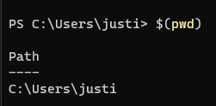
Ok so even though UI directory is in the Path
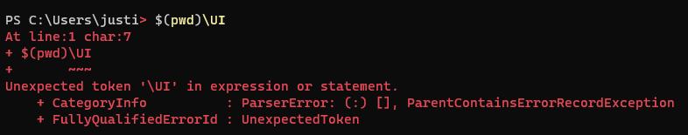
Shells might have their own version of $(pwd)
Try running the command in terminal
absolute
C:\Users\justi\Kafka\kafka-dotnet-getting-started\getting-started.properties
relative
getting-started.properties

We have a winner
dotnet run --project producer.csproj C:\Users\justi\Kafka\kafka-dotnet-getting-started\getting-started.properties
So with the absolute path, we get past the error messages and it appears to read the config file, but then

%3|1656853339.255|FAIL|rdkafka#producer-1| [thrd:sasl_ssl://and admin bootstrap.servers=pkc-l6wr6.europe-west2.g]: sasl_ssl://and admin bootstrap.servers=pkc-l6wr6.europe-west2.gcp.confluent.cloud:9092/bootstrap: Failed to resolve 'and admin bootstrap.servers=pkc-l6wr6.europe-west2.gcp.confluent.cloud:9092': No such host is known. (after 0ms in state CONNECT)
There was something wrong with the bootstrap servers address in the config file, so updated that to what was on the website(https://confluent.cloud/) and it started working fine.

https://docs.confluent.io/platform/current/clients/confluent-kafka-dotnet/_site/api/Confluent.Kafka.html?_ga=2.13740468.2021154912.1656846392-42273396.1656846392

